MINI PROJECT REPORT

ON

**INTELLIGENT VIRTUAL ASSISTANT (GYANI AI)**

SUBMITTED FOR THE PARTIAL FULFILLMENT OF

THE B.TECH.CSE(AIML)SECOND YEAR III SEMESTER COURSE

INTERNSHIP/MINI PROJECT-BCC 351

AT

DRONACHARYA GROUP OF INSTITUTIONS



BY

1. AMIT PRASAD (17384)

2. JATIN CHAUDHARY (17393)

3. ANUSHIKA JHA (17388)

Affiliated to

Dr A P J ABDUL KALAM TECHNICAL UNIVERSITY, LUCKNOW.

**ACADEMIC SESSION 2023-24(ODD)**

**CERTIFICATE**

This is to certify that the Intelligent Virtual Assistant (GYANI AI) project is the result of my work and has not been copied from any other source, including the Internet. Any resources, texts, or subject matter used during the development of this project have been duly acknowledged in this report. This project report is submitted in partial fulfillment of the requirements for the second-year third-semester course of B.Tech (Branch) with the code BCC 351, in accordance with the curriculum of Dr. APJ Abdul Kalam Technical University, Lucknow.

I confirm that the content presented in this report is not being used for any other

purpose and has not been submitted elsewhere.

**TEAM MEMBERS:**

1. AMIT PRASAD (17384)
2. JATIN CHAUDHARY (17393)
3. ANUSHIKA JHA (17388)

Date: 28-01-2024

**INTELLIGENT VIRTUAL ASSISTANT**

GYANI AI emerges as a groundbreaking virtual assistant, designed to provide unparalleled support across various domains, including general assistance, developer collaboration, medical guidance, counseling, Wikipedia searches, and newsletter creation. Crafted with precision and incorporating advanced technologies, GYANI AI offers users an all-encompassing solution, backed by a thoughtful selection of tools and a journey marked by overcoming significant challenges.

**Key Features:**

**General Assistance:**

GYANI AI excels in everyday tasks, employing natural language processing (NLP) to ensure fluid and context-aware conversations.

Task automation and reminders enhance user productivity.

**Developer Collaboration:**

Tailored for developers, GYANI AI integrates with popular development environments, offering code analysis, debugging assistance, and real-time collaboration features.

Version control tools ensure a seamless development workflow.

**Medical Guidance:**

Leveraging extensive medical databases, GYANI AI provides accurate health information while adhering to strict privacy measures and healthcare compliance.

Medication management features assist users in maintaining their health regimens.

**Counseling Services:**

Featuring empathetic conversational AI, GYANI AI supports users seeking mental health assistance.

Privacy-focused communication ensures a secure and confidential counseling experience.

**Wikipedia Searches:**

GYANI AI conducts thorough searches on Wikipedia, extracting and summarizing relevant information to provide concise and accurate responses.

Its ability to navigate vast knowledge bases enhances the user's access to information.

**Newsletter Creation:**

Assisting users in crafting newsletters, GYANI AI considers user preferences and automates distribution processes for efficient communication outreach.

**Tools Used in AI Development :**

1. **Machine Learning Frameworks**: Employed to train the AI model and enhance its adaptive learning capabilities.
2. **Privacy and Security Tools**: Implemented robust measures to safeguard user data in compliance with industry standards.
3. **API OF CHATGPT** : API by signing up on the OpenAI platform, obtaining API keys, and making requests to integrate GPT-3 into their applications for tasks like chat-based conversations and language generation.
4. **BOTPRESS :** Botpress is an open-source conversational platform that allows developers to create, manage, and deploy chatbots. Botpress is designed to be flexible, scalable, and extensible, making it a popular choice for businesses and developers looking to implement chatbot solutions.

**Challenges Faced:**

1. **Data Privacy and Security**: Balancing the need for personalized assistance with strict privacy standards, especially in medical and counseling contexts.
2. **Multi-Domain Integration**: Ensuring smooth transitions between diverse domains posed challenges in maintaining a cohesive user experience.
3. **Connecting with API** : Understanding how to make API requests and handing the asynchronous nature of fetching data.

**Methodology:** 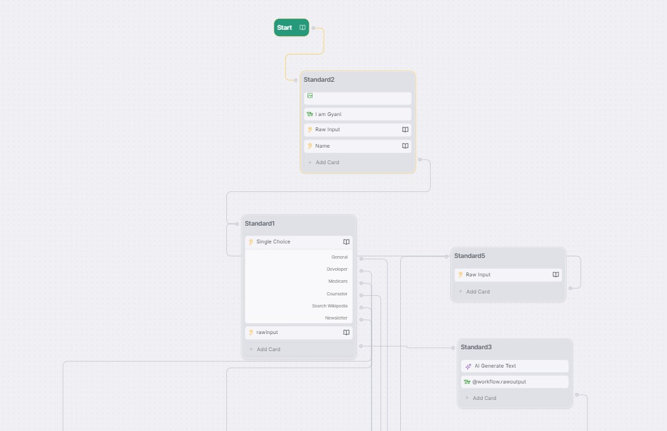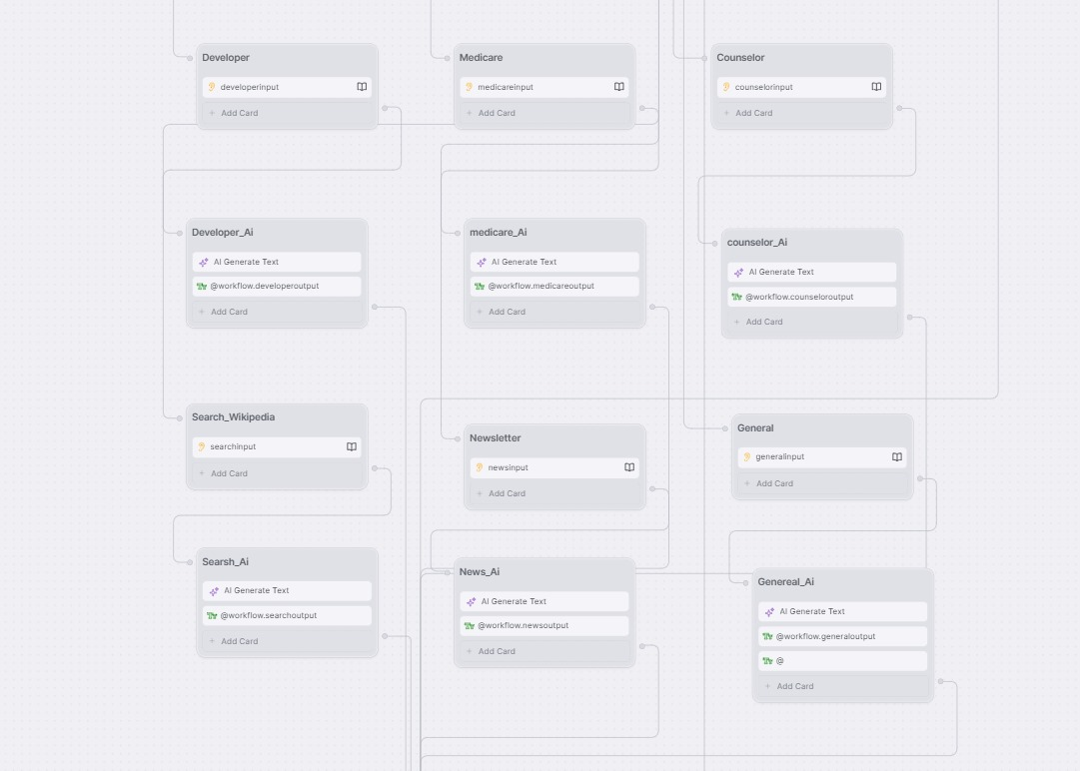



**References:**

1. <https://www.bootpress.org/>
2. [ChatGPT (openai.com)](https://openai.com/chatgpt)

<https://chat.openai.com/share/7b5c03ed-35fb-411c-89c7-a6ed054de6e0>